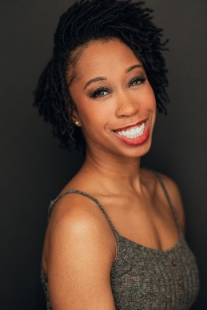
Daphne Marcelle Lee

SAG/AFTRA – (Eligible) | AEA

Height: 5’3” Eyes|Hair: Dark Brown Vocal: Alto Pronouns: She|Her

Television/Film
WuTang: American Saga (Hulu) Dancer/Co-Star Mario Van Peebles
Life Of An Actress (Fillm) Dancer Wendy Seyb

Theatre
Disney’s The Lion King (Broadway) (Current) Dancer/Sarabi US Mark Brandon

Live/Stage Performances
Dance Theatre of Harlem Dancer Virginia Johnson
Collage Dance Collective Dancer Kevin Thomas/Marcellus Harper
Alvin Ailey II Dancer Troy Powell
Oakland Ballet Dancer Graham Lustig
Black Iris Project Dancer Jeremy McQueen

Industrials
Beyonce-Mrs. Carter World Tour Dancer Frank Gatson

Print
Bloch Dancewear Model
NudeBarre Tights Model
Capezio Dance Model
Gaynor Minden (Pointe Shoes) Model

Education|Training
Dance: MFA, Hollins University, BFA Ailey/Fordham
Acting: Nikiya Mathis
Voice: Phillip Skinner

Special Skills
Cheerleading, Cooking, Hair Styling, Double Dutch, Partnering, Tap dancer, Salsa, African dance, Swing dance, Driver’s License, Nursing Skills, Pointe, British Accent, Southern Accent, Pilates teaching, Caregiving.

